ORTHODOX
MISSION
NETWORK

OCTOBER 2014 newsletter

_________________________________________________________________________

Upcoming Events
- December 1-2, 2014 - Annual meeting of the OMN expanded work group in Athens, Greece
- End of May or beginning of June 2014 - Mission training in Shen Vlash, Albania
We need your prayers and proposals for the mission training which is being planned for the next year.

Report of the Russian Orthodox Mission Society
In 2014, the Russian Orthodox Mission Society completed the following projects:
- We printed the first Orthodox Christian book in the Vietnamese language. It is called
"300 Sayings of the Ascetics of The Orthodox Church" and includes the wisdom of great Christian teachers from different ages and countries. We shared these books with local Christians during two trips of our missionaries to Vietnam.
- We printed three Orthodox books in the languages of the Philippines: 1) "What is the Orthodox Church?" in Cebuano, 2) "How the Orthodox Christian faith differs from other denominations which call themselves "Christian churches" in Tagalog, and 3) the Typika (the Orthodox service for laymen) in Cebuano. In the Philippines, the Orthodox mission has existed since 1990, but until now there were no Orthodox Christian books in the local languages.
- We provide financial support for one Orthodox Christian secondary school in Nyeri, Kenya.
- We sponsored the purchase and installation of a well-boring machine in one village of the Chandrapur region of India. In this village there is an Orthodox community of local converts, and the people have had difficulties due to lack of water.
- We supported an existing mission of Russian Orthodox Church in Taiwan with financial support, with information, and by sending missionaries.
- For the benefit of foreign missions, we issued two podcasts for Android phones: free versions of the text of the book "300 Sayings of The Ascetics of The Orthodox Church" in the English and Chinese languages.
There is a link for downloading:
https://play.google.com/store/apps/details?id=ru.orthomission.tristaslovmudrosti
- We printed the first Orthodox prayer book in the Urdu language for Orthodox communities in Pakistan.

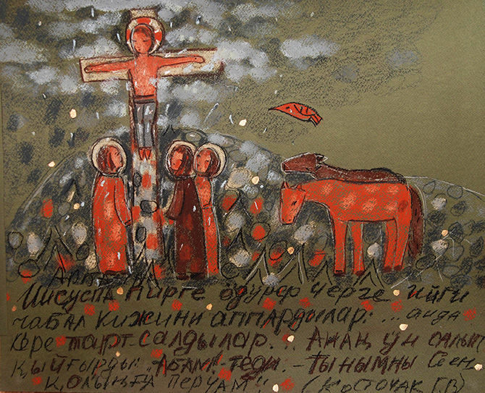

“Turning to God” Mission of the Orthodox Church among Indigenous Communities of Southern Siberia
“Return unto Me, and I will return unto you, saith the Lord.” (Malachi 3:7)
Mission development
Mission development was started by the missionary department of the Kemerovo diocese in 2006. Its first edition received approval from the Moscow Patriarchate’s Synodal Missionary Department and was awarded a diploma in a missionary programs contest that took place during the XV International Christmas Readings.
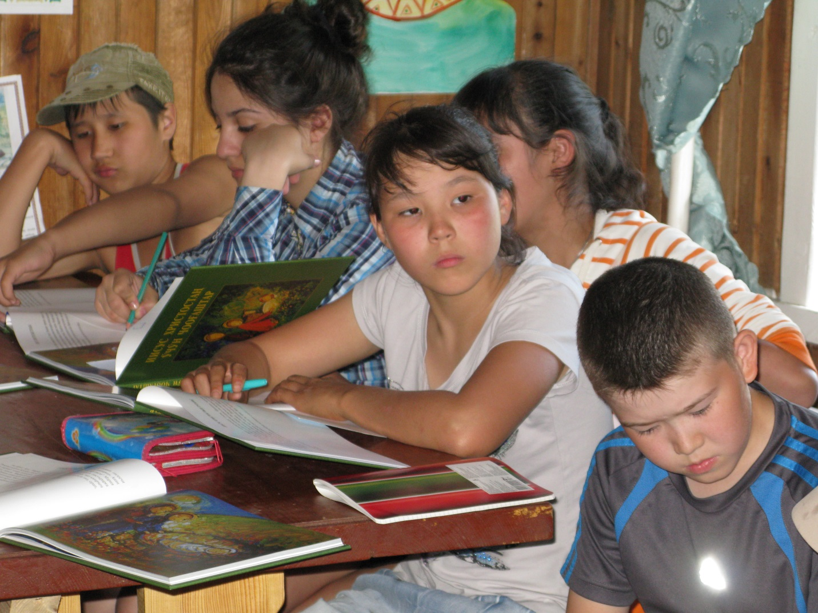
Scope and objectives of the mission
This includes the opening of Orthodox mission parishes in indigenous population habitats and ensuring their sustainability, restoration of Christian coenobitic living principles in national settlements, and the entrenchment of a Christian world view in traditional national culture. Mission methodology is based on principles that have already been tested in the XIX century in the Altai Ecclesiastical Mission activities:
- Principle of participation
- Principle of adaptation
- Principle of succession
- Principle of cooperation
Mission incorporates work in four directions corresponding to the basic principles of the mission:
Implementation of the Succession Principle:
- Studying the legacy of Altai missionaries
- Gathering statistical data on the denominational affiliation of the indigenous population of Southern Siberia
- Identifying Orthodox culture bearers among representatives of the senior generation (prayers, stories etc., including those in national languages)
- Searching for and publishing of existing Orthodox literature in national languages
- Historical reenactment of the process of adoption of Christianity by indigenous peoples of Southern Siberia
- Working with representatives of the academic community studying issues of the effects of Christianity on ethno-cultural processes
- Promotion of the activities of the Altai Ecclesiastical Mission through media publishing, television appearances, the creation of internet resources, and the publication of scientific (historical) literature
Implementation of cooperation principle:
- Participating in joint activities with national organizations
- Structuring of a positive dialogue with representatives of national intellectuals and national non-governmental organizations
- Participating in existing social and cultural programs of national non-governmental organizations or their joint organization
- Organizing and holding of conferences, round-tables etc. to engage the mass media in the discussion of “Orthodox Christianity and national culture”.
Implementation of participation principle:
- Arrangement of summertime missionary camps and mission work camps of Christian youth in close proximity to settlements of indigenous peoples
- Medical aid to the indigenous population
- Humanitarian mission — support by provision of clothes, footwear, seeds, etc.
- Cultural and educational events (concerts, performances, video lectures etc.)
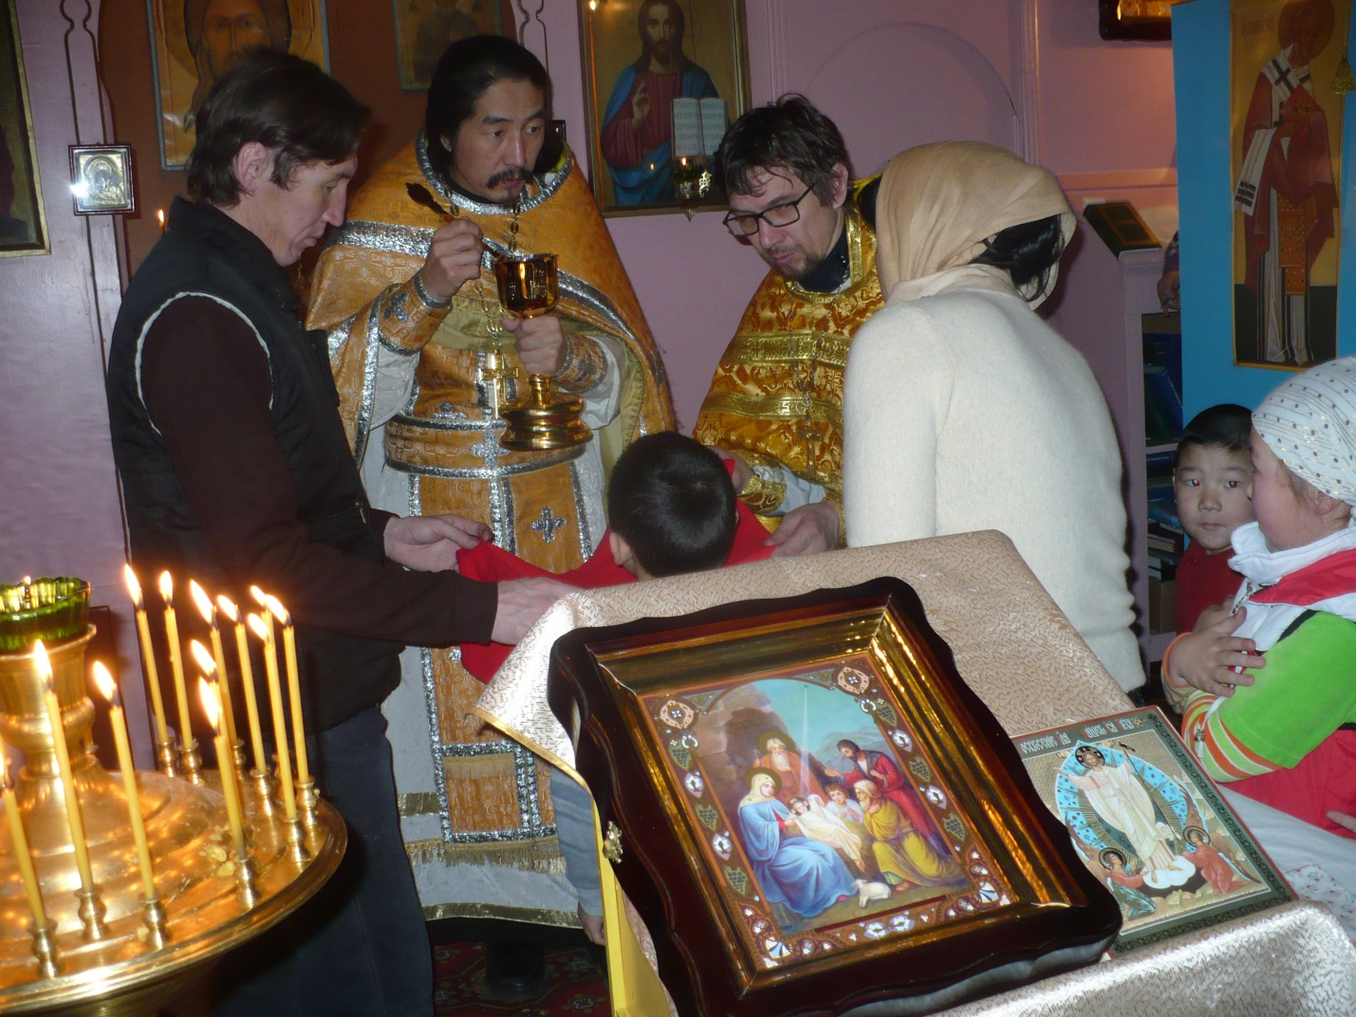
Implementation of adaptation principle:
- Translating the prayers, services, and texts of the Holy Scriptures into national languages
- Distributing of Christian literature among the indigenous population
- Holding worship services in churches with indigenous and mixed populations in national languages
- Coordinating the activities of clergy whose wards are located on the indigenous population’s residential territory
- Training of clergy and minor orders from among the indigenous population

Mission Implementation in Kuzbass archdiocese of the Russian Orthodox Church
At the current time, the mission is being implemented among the Shorian population in communities of the Kemerovo region: in Tashtagol area, first of all, in the Ust-Anzas and Mrassou settlements and Sheregesh township, and among the Teleutians in the Bekovo village of the Belovo area and Teleuty settlement (Novokuznetsk).
“St. Makarii of Altai Foundation” Transregional Public Foundation
To ensure successful implementation of the mission, a public foundation was created that bears the name of the first Apostle of Altai — Archimandrite Makarii Glukharev. More detailed information on the “Turning to God” mission and St. Makarii of Altai Foundation can be obtained by applying to the head of Foundation, Fr. Igor Kropochev:
fr.igor.kropochev@gmail.com

Thirty Years: New Horizons and New Challenges
By Fr. Martin Ritsi, Executive Director, Orthodox Christian Mission Center, USA
(This article was originally written for OCMC’s magazine in commemoration of its 30th anniversary this year.)
The desert wash was an expansive, sandy channel winding through the hot and remote Kenyan landscape. Over the years, it had filled occasionally with water from faraway rains that bring life and hope to those who survive in this harsh climate. Though the sands had been dry for some time, the river wash awaited an unseasonal watering so that it could participate in transmitting the blessings of God. During the night, the skies lit up from lightning flashes on the horizon. Then, in the early hours of the morning, the river began to flow, violently at first, but then subsiding to a steady stream that beckoned to the villagers to come and receive the gift of life. On that day, at the culmination of a year’s catechism, over 100 people were immersed in these waters that miraculously appeared to receive baptism into Christ!
The baptism in Nakabosan and the evangelism and establishment of the Orthodox Church in Turkana, Kenya, are a testimony and symbolic statement of the growth of Orthodox missions and the work of the OCMC, now celebrating its 30th year of ministry and 20thyear as a pan-Orthodox agency. Present at the baptism were three of the 98 missionaries who have served under OCMC over the last 30 years and two of the 17-person multi-jurisdictional OCMC staff in St. Augustine, Florida. Two of the 259 local Kenyan clergy were instrumental in bringing this village to Christ. Not far from the baptism site was one of 37 churches built by OCMC. There was also a water well and a school that were built as part of the holistic missionary outreach that addresses both the spiritual and material conditions of those evangelized. The nearby church was built by individuals who participated on an OCMC Mission Team together with local Orthodox from the neighboring village of Loupwala.
Each aspect of this event was only a dream in 1985 when OCMC first began. At that time, missionary work was questioned - at home and internationally. Our efforts were led by a staff of just a couple of people. There was no missionary training center. No missionaries had been sent. Mission teams were not yet thought up. The seminary to train today’s many indigenous clergy in Africa was just opening. The thought of being involved in evangelizing unreached peoples from remote tribes, or participating in the resurrection of an Autocephalous Church such as in Albania, was beyond our means. There were only a handful of indigenous mission clergy, and Orthodox mission work was rare.
But today, the past three decades have seen exponential growth of missions. Orthodoxy worldwide has re-entered the scene with missionary work established on 6 continents and new efforts beginning regularly. This growth, though, is not representative of reaching maturity. Rather, it represents a solid foundation that a house can be built upon. With this foundation, we can now look forward to new horizons. We can engage in new possibilities that were but a dream 30 years ago.
At the same time, as we look forward to new possibilities we must also respond to new challenges. One of these challenges is the understanding of missions as a central aspect of our faith. Even though the presiding leaders of our Mother Churches recently asserted in a joint statement that the “evangelization of those who do not believe in Christ, constitutes the supreme duty of the Church,” last year only 18% of Orthodox parishes in North America participated in international missionary work through OCMC. Involvement and support of Orthodox missions have grown dramatically in the USA, but they show only a fraction of our potential. There is a need to expand our vision to include this “supreme duty,” entrusted to us by the Lord. Over one billion people….one billion have not yet heard the gospel message. If our primary mode of operation remains to focus on our local needs, they will not hear – at least not from the followers of the Orthodox faith. On the other hand, if so much has been done through only 18% of the Orthodox parishes in the United States, think of what the possibilities would be if more parishes participated!
Another challenge that we are now able to address is a result of the growth and success of the past 30 years. Just as a child goes through natural stages of development, so do institutions, ministries, parishes, and mission Churches. One of the next steps in the development of Orthodox missionary Churches today is that of self-support and sustenance. Parishes, seminaries, and national Churches are established on many continents. In the startup phase of these churches, material aid for infrastructure, training, and day-to-day operations was essential. This enabled the rapid growth and establishment of the Church. As these Churches mature, they have the potential to become mission-sending Churches. But first, the ability to meet basic needs, such as support and training of clergy, along with funding their hierarchs and national ministries must be tackled. Addressing self-support is an exciting area OCMC has focused on in the most recent years and one which will develop in the years to come.
Orthodoxy is spreading in the world today. People who had not heard the Gospel before are coming to Christ. The Church is being established and Jesus’ love is being shared. After 30 years, a solid foundation for missionary work is laid through a pan-Orthodox effort. Within that foundation are a myriad of lives that have been shaped, thousands of souls that have been touched, and countless miraculous examples of God showing His presence and transforming those who draw near to Him. We hear in the Psalms, “Unless the Lord builds the house, in vain do the laborers toil” (Psalm 127). May we now build upon the foundation laid over these three decades, joyfully rise up to new opportunities on the horizon, and diligently engage the challenges of today, so that God’s love may be proclaimed to, and by, all nations.

